CLEANING UP OUR ACT: ENVIRONMENT
AND HOMETOWN SOLUTIONS

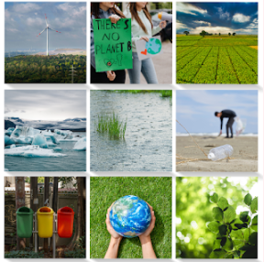

USEFUL VOCABULARY

Litter and Waste

- litter (noun)
- waste (noun)
- recycle (verb)
- neighbourhood (noun)
- cut down (phrasal verb)
- effective (adjective)

Air Pollution

- pollution (noun)
- allergy (noun)
- reduce (verb)

The Future of Water

- water usage (compound noun)
- water shortage (compound noun)
Energy Efficiency

- energy efficiency (compound noun)
- unplug (verb)
- charger (noun)
- light bulb (compound noun)

Climate Change

- climate change (compound noun)
- accurate (adjective)
- exaggerated (adjective)

QUESTIONS

Litter and Waste

- Which items do you recycle?
- How frequently is the rubbish collected in your neighbourhood? Is there only one kind of rubbish being emptied, or are there different kinds?
- Is it easy to recycle in your neighbourhood?
- What's the most effective way to stop people from littering? Should the fines be higher, or should education be better?
- Are companies more or less environmentally responsible now than they were in the past? What can companies do to cut down on waste and help the environment?

Air Pollution

- Have you ever noticed the air quality being particularly bad? If so, explain how.
- What are the main causes of air pollution in your hometown or country? Would you say it's traffic, factories or anything else?
- How does air pollution affect your daily life? For example, do you get allergies?
- What's the most effective way a city can reduce the pollution caused by cars?
- If you were a mayor, what's the first thing you would do to protect the air quality in your area?

The Future of Water

- In what ways can we save more water?
- Have you ever experienced a water shortage or been asked by the government to reduce your water usage?
- What are the long-term dangers to the world's oceans?

Energy Efficiency

- What small things do you do every day to save energy at home? Do you make sure you turn off the lights when you leave a room? Do you unplug your charger?
- At home, do you use energy-saving light bulbs? If so, do you think they make a difference?

Climate Change

- What changes in the weather have you noticed in your lifetime that might be linked to climate change?
- Which country or region do you think will be most affected by climate change in the next 20 years?
- Do you believe that media reporting about climate change is accurate or exaggerated?
- What things are people giving up to help slow down climate change? Flying? Eating meat?

You can find a growing library of B1/B2 lesson plans at https://dailyconversationprompts.blogspot.com/

© Diana F

